College Management

1. INTRODUCTION

A college management system project allows schools and universities to keep track of their enrolment, students, teachers, attendance, fees, scheduling and other activities related to tertiary education tasks. It creates automatic reports for data –driven decision-making on all college management aspects. This college management system project report discusses everything you need.

* 1. Overview

The project aim is to provide real-time knowledge for all the students who have basic knowledge of Salesforce and Looking for a real-time project. This project will also help those professionals who are in cross-technology and want to switch to Salesforce. With the help of this project they will gain knowledge and can include it into their resume as well.

* 1. Purpose the use of this Project

The study of management will provide you with the tools and skills needed to land leadership positions, head up your own company, as well as mange teams, individuals, and organizations effectively. Studying management will also position you for outstanding earning potential.

1. Problem definition & Design Thinking
   1. Empathy map

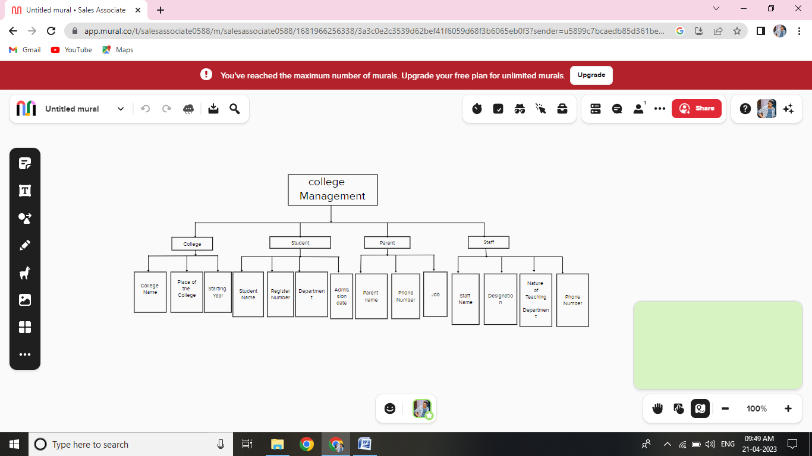

* 1. Ideation & Brainstorming Map

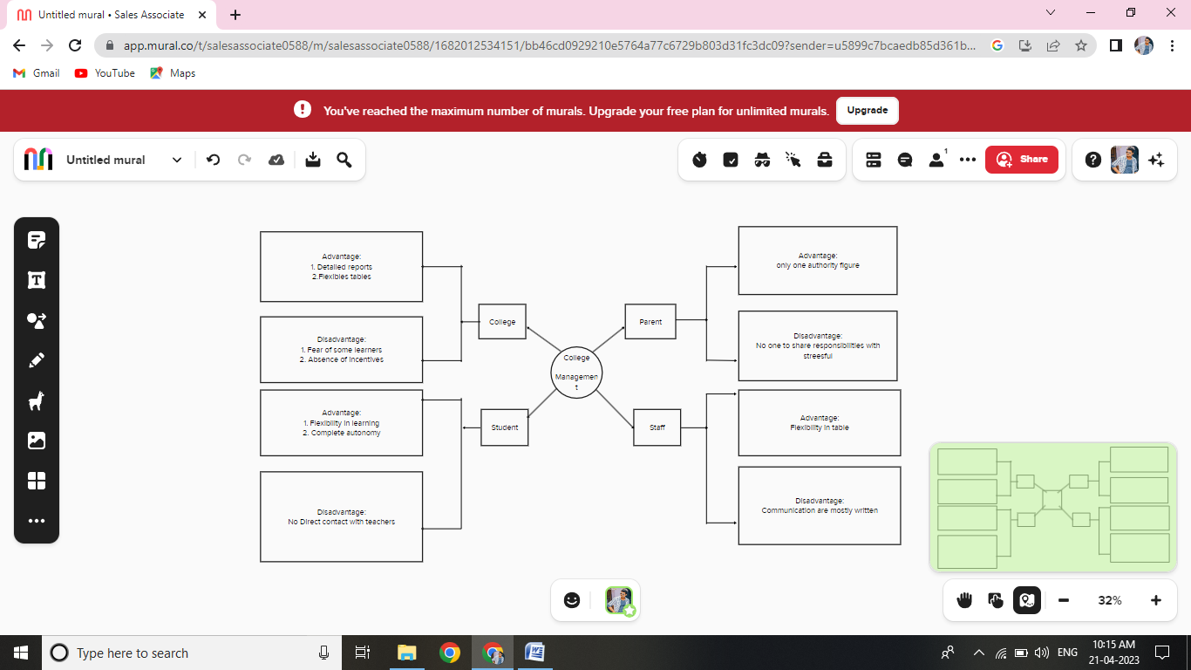

3 Result

3.1 Data Model:

|  |  |  |
| --- | --- | --- |
| S. No | Object | Object Field type |
| 1 | College | text |
|  | |  |  |  | | --- | --- | --- | | Field | Field Name | Field type | | Field 1 | College Name | Text | | Field 2 | Place of the college | Text | | Field 3 | College Address | Text | | Field 4 | Starting Year | Number | | Field 5 | District | Picklist | |  |
| 2 | Student | Text |
|  | |  |  |  | | --- | --- | --- | | Field | Field Name | Field Type | | Field 1 | Student Name | Text | | Field 2 | Register Number | Text | | Field 3 | Department | Picklist | | Field 4 | Phone Number | Phone | | Field 5 | Admission Date | Date | | Field 6 | Admission Fees | Currency | |  |
| 3 | Parent | text |
|  | |  |  |  | | --- | --- | --- | | Field | Field Name | Field Type | | Field 1 | Parent Name | Text | | Field 2 | Phone Number | Phone | | Field 3 | Aadhaar Number | Number | | Field 4 | Job | Text | | Field 5 | Address | Text | |  |
| 4 | Staff | Text |
|  | |  |  |  | | --- | --- | --- | | Field | Field Name | Field Type | | Field 1 | Staff Name | Text | | Field 2 | Designation | Text | | Field 3 | Phone Number | Phone | | Field 4 | Nature of Teaching Department | Picklist | | Field 5 | Email Id | Email | | Field 6 | Address | Text | |  |  |  | |  |

3.2 Activity & Screenshot

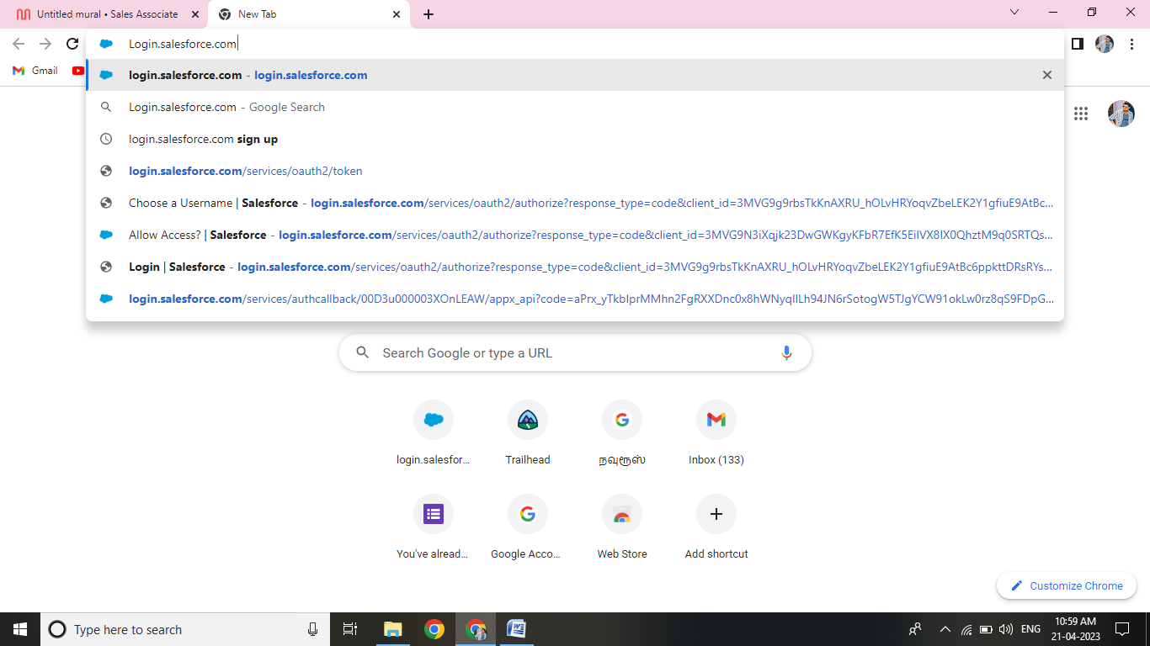

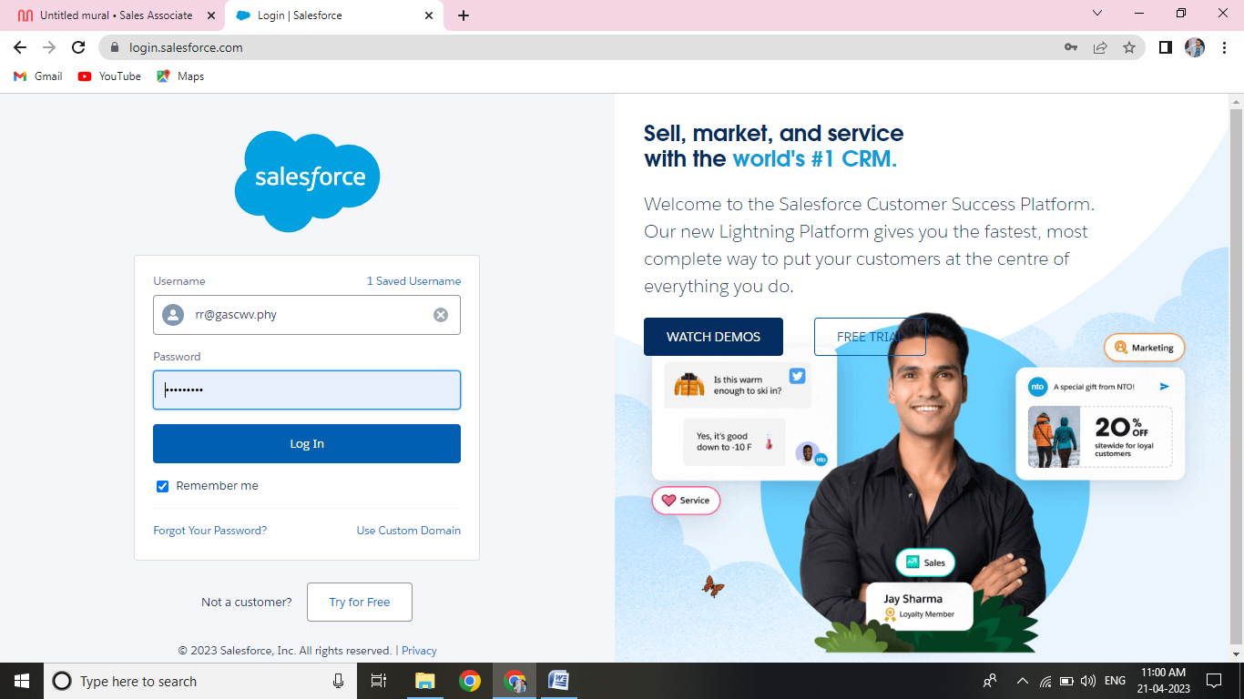

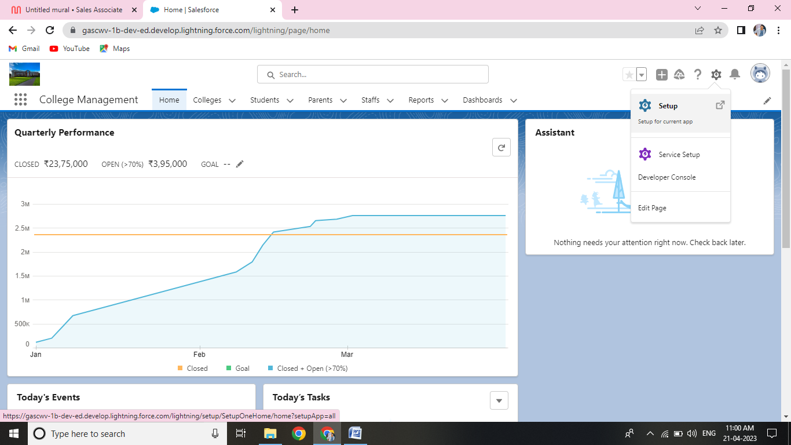

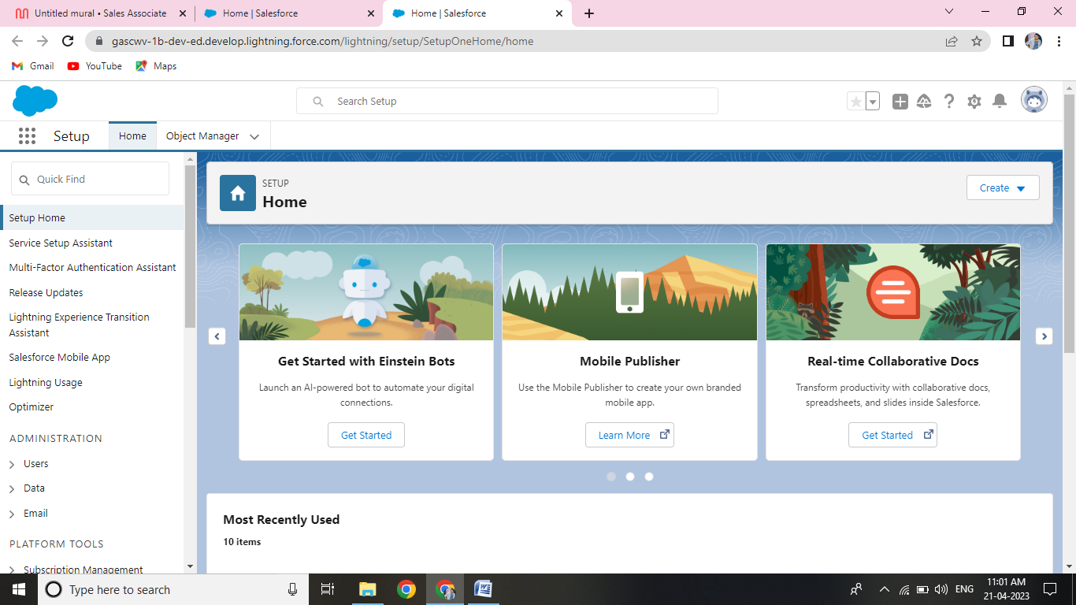

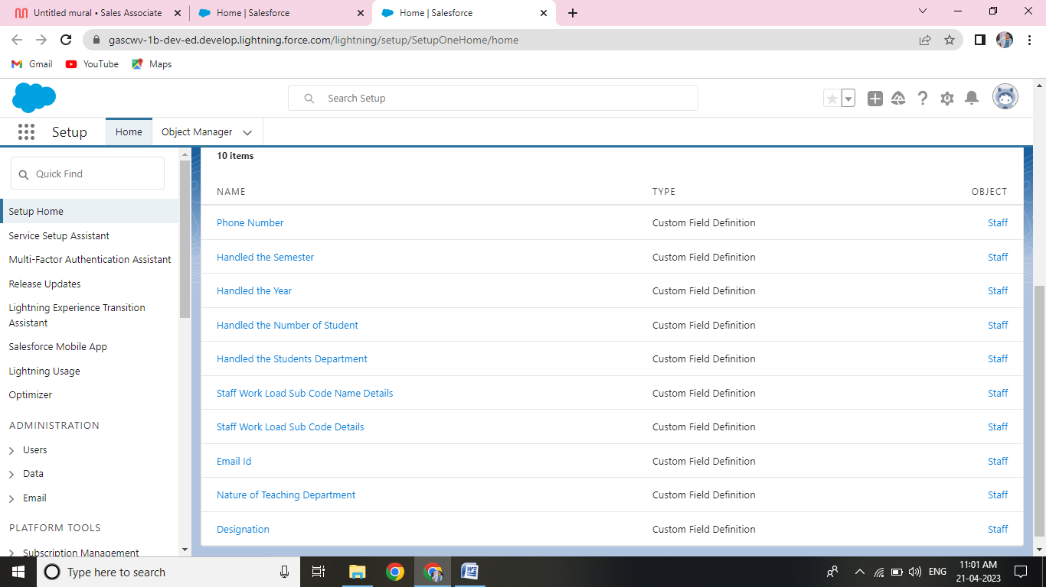

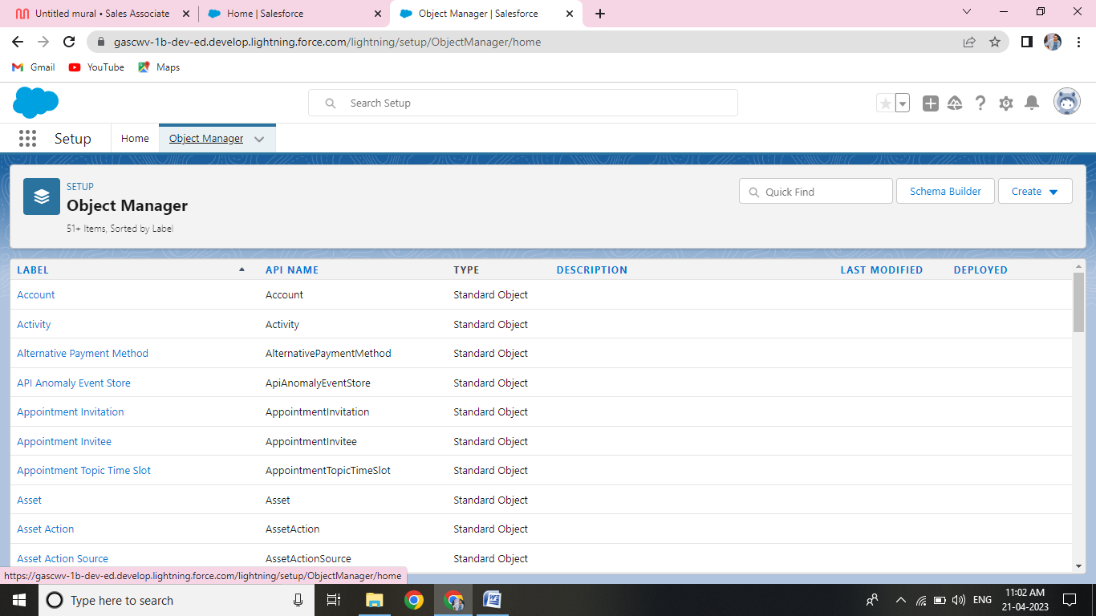

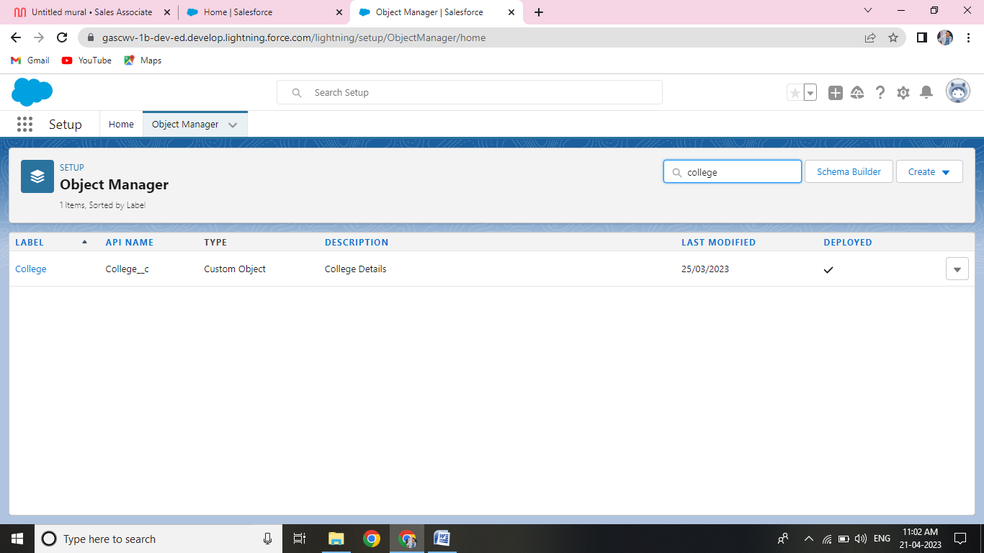

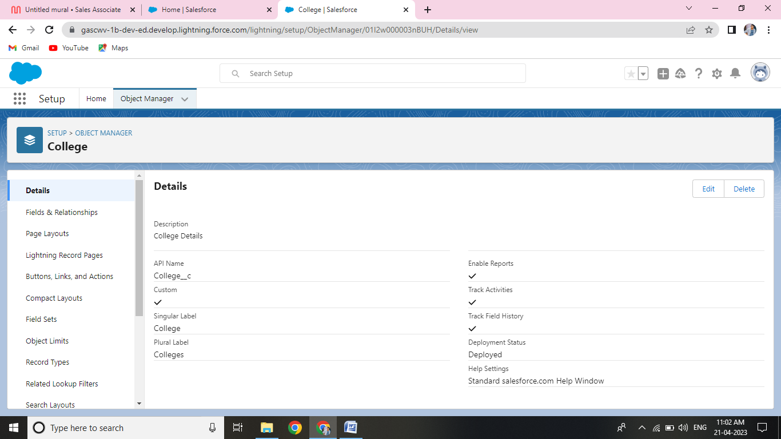

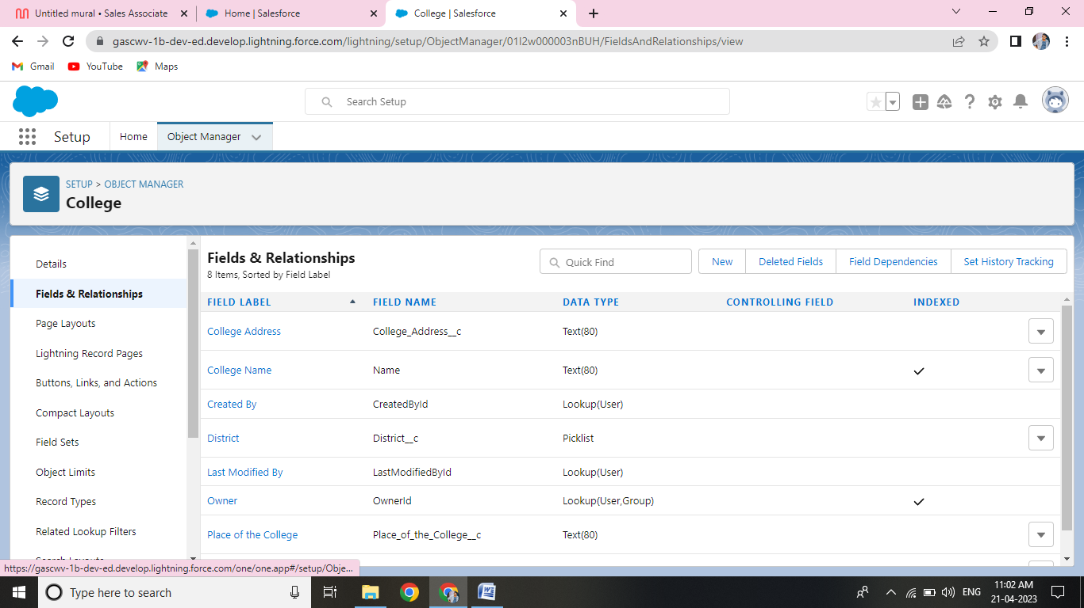

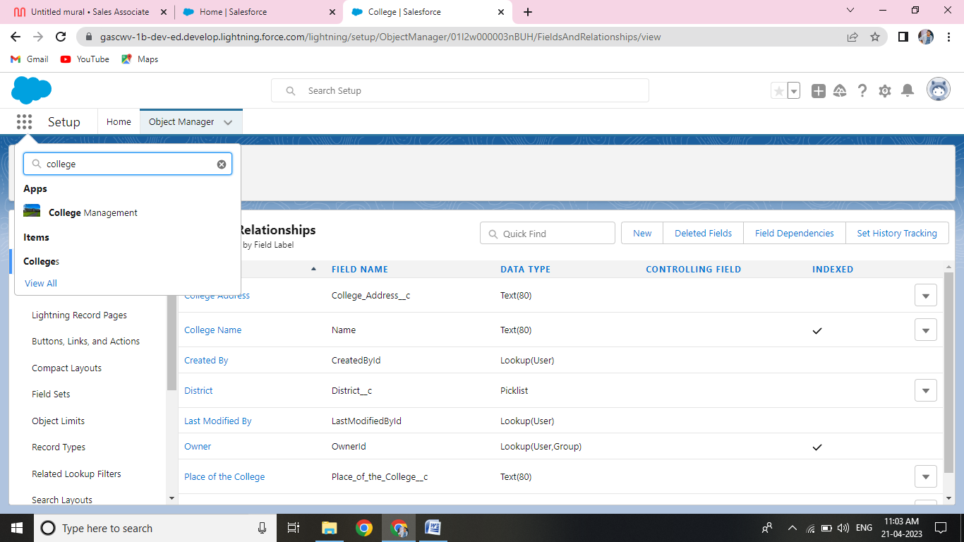

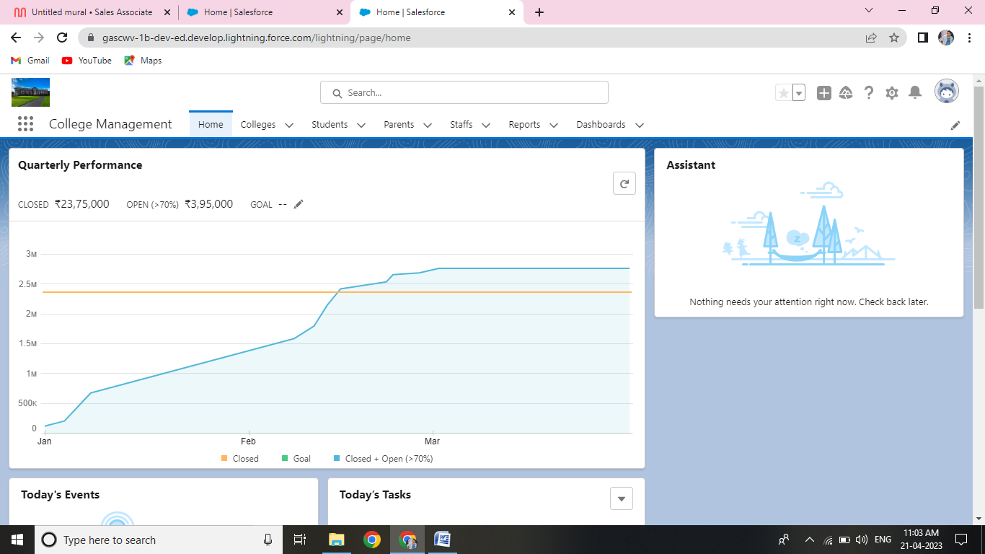

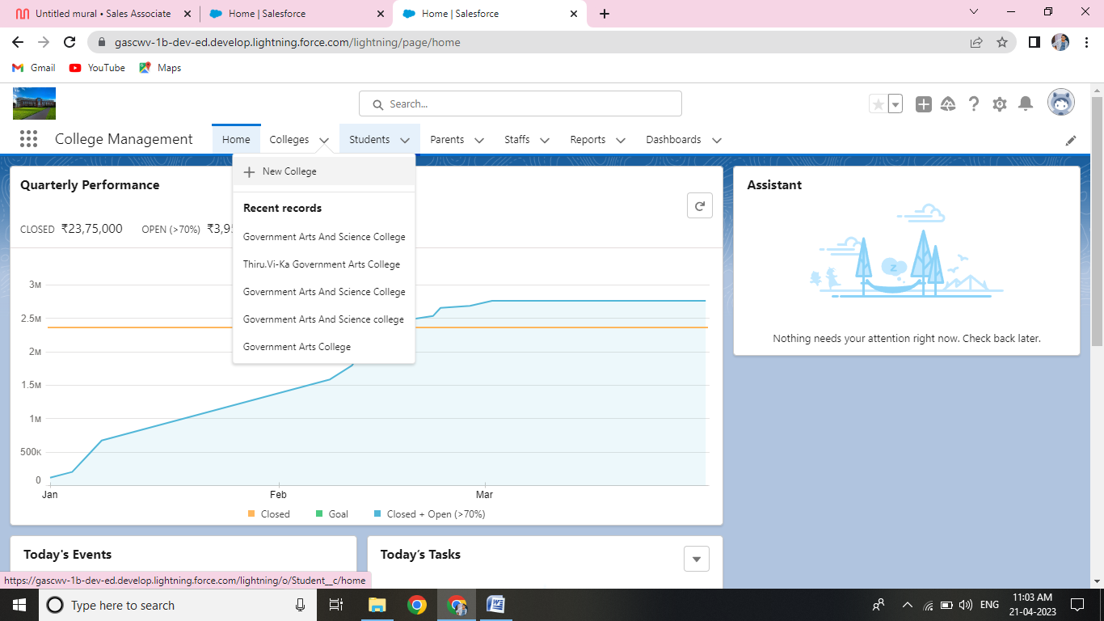

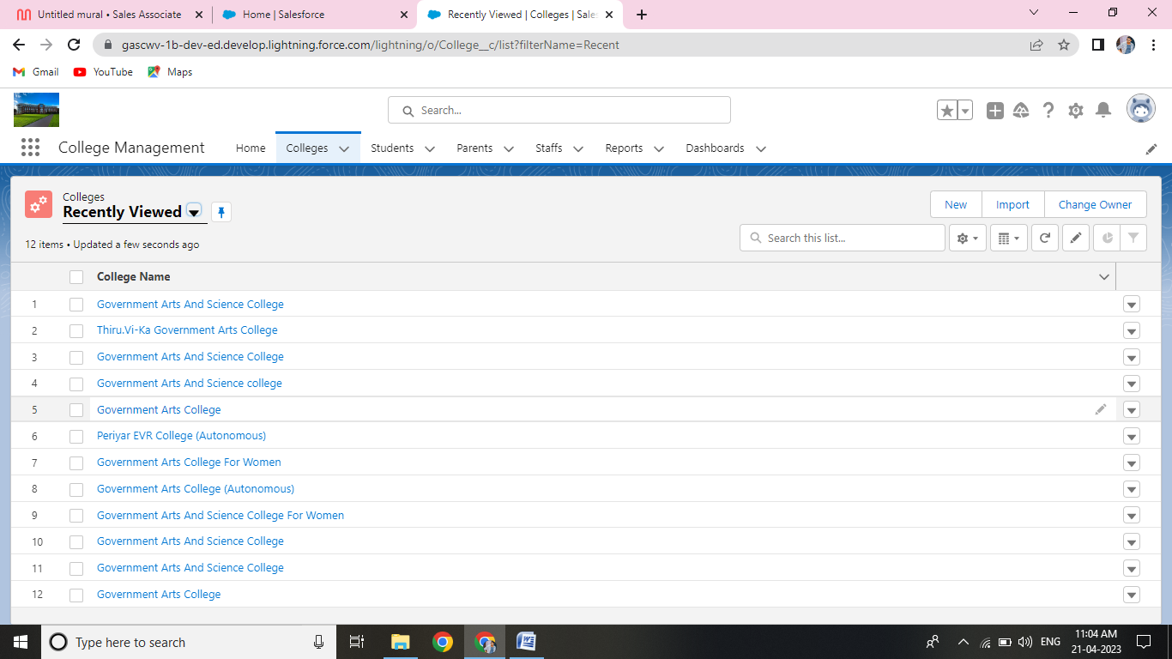

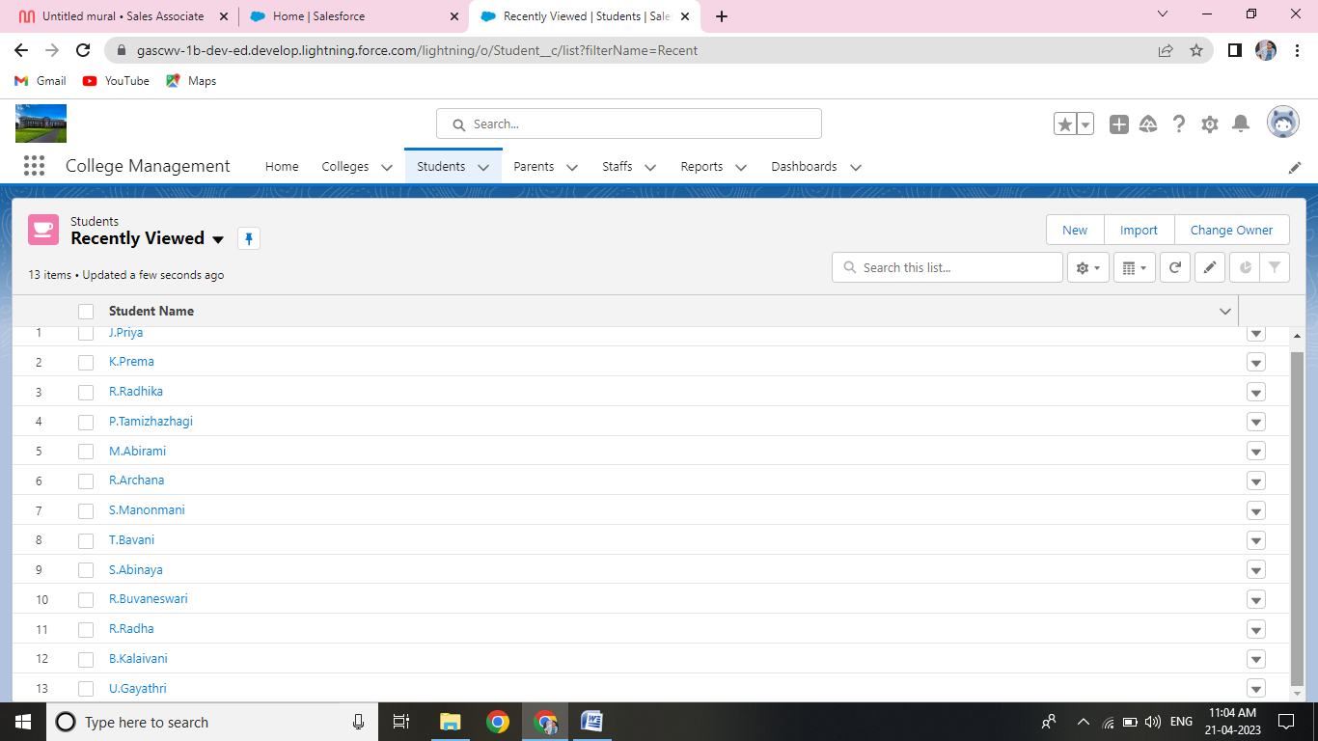

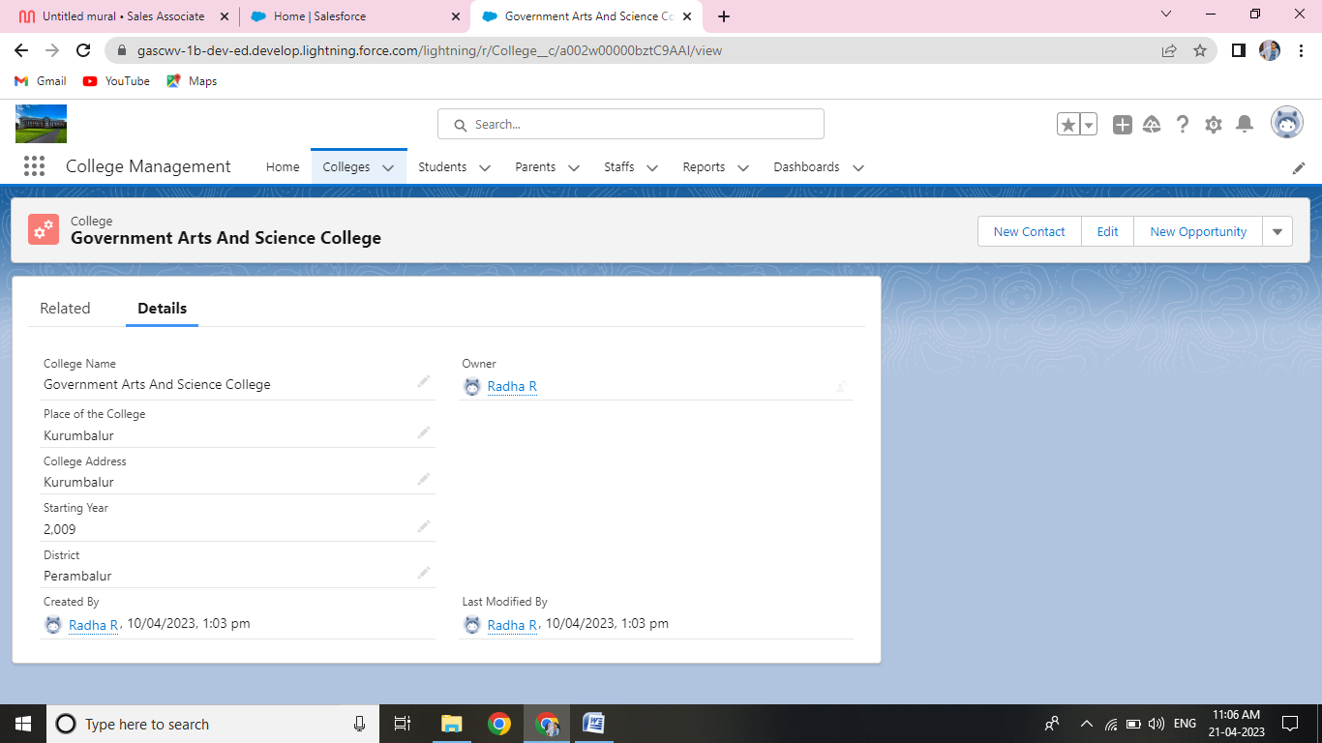4. Trailhead Profile Public URL

Team Lead: https://trailblazer.me/id/radha29

Member 1: https://trailblazer.me/id/bramu19

Member 2: https://trailblazer.me/id/bavat3

Member 3: https://trailblazer.me/id/tamip8

5. Advantages & Disadvantages

Advantages:

* Several Controls help the Application to be friendly to the uses.
* The entire project maintenance is made simpler and more adaptable.
* Internet access is possible.
* It offers great degree of security employing various protocols.

Disadvantages:

* More Money
* More Time
* More Manpower
* More Work
* Less Work Result
* No Accuracy

6 Application

Graphical User Interface: For those of you who are up to the challenge, you can extend your PHP installation to maintain desktop applications. It is a Challenge because it requires some extensive knowledge of PHP and it might be easier to maintain application in other language, Then you may adopt to get started creating GUI applications.

7 Conclusion

This paper presents a method for increasing information requested by student with the use of automated college management system. In this instead of direct contacting with direct contacting with the faculty the student can directly checks the results from the system if the student is registered in CMS.

CMS helps educational institute to do regular activities accurately, fastly and reliably.

8 Future Scope

This project deals with the various functioning in college management process. The main idea is to implement a proper process to system. In our existing system contains a many operations registration, student search, fees, attendance, exam records, performance of the student etc. All These Activity Takeout Manually by administrator.

In our model, it deals with the operation in system.